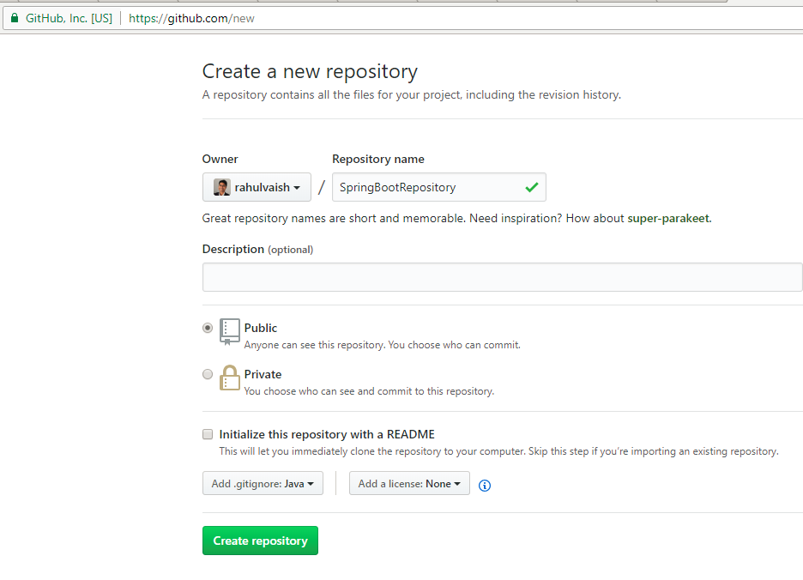

After creating the repository, copy the URL:

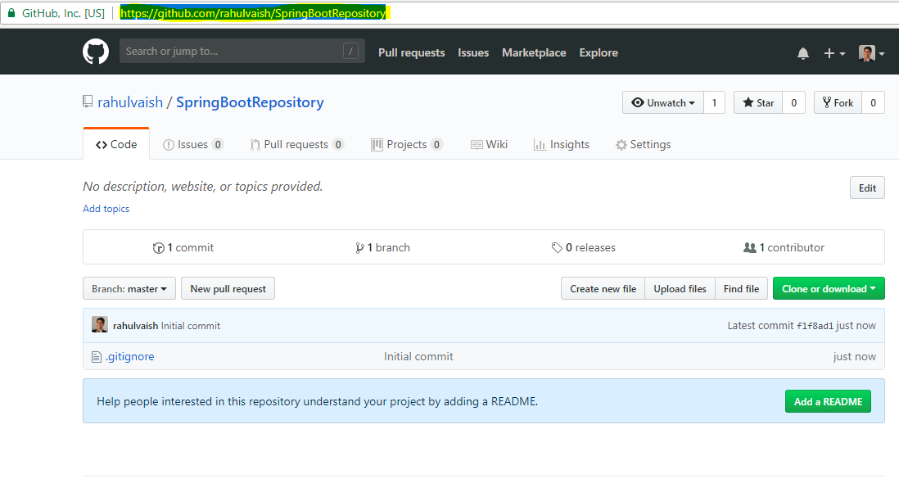

In any folder Right Click-> Git Clone

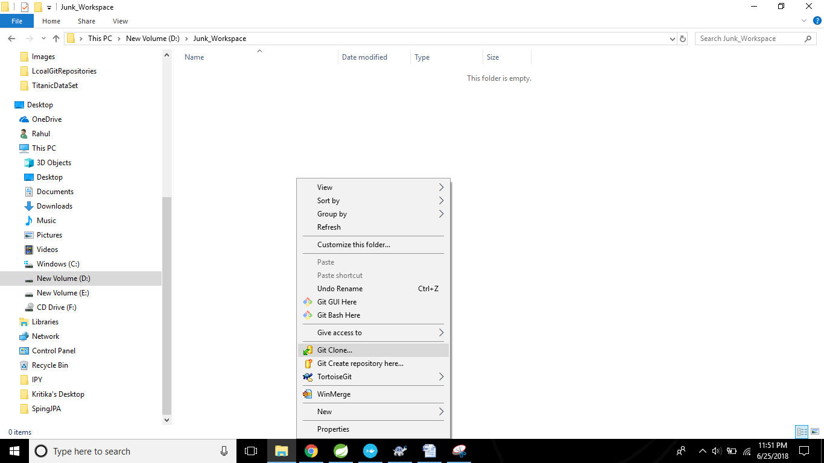

Paste the URL,that was copied earlier:

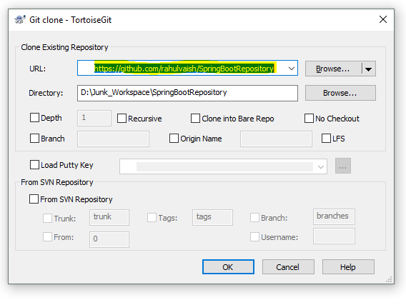

Click on OK.

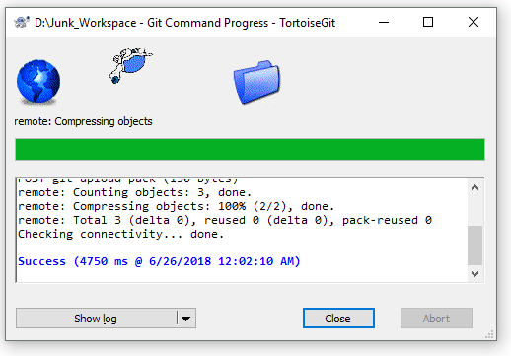

Just to be curious, if we see what got cloned from an empty repository:

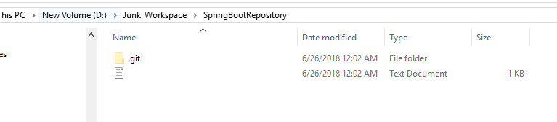

**We can also clone any repository like as below:**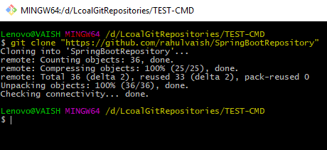

Now copy the project from your workspace

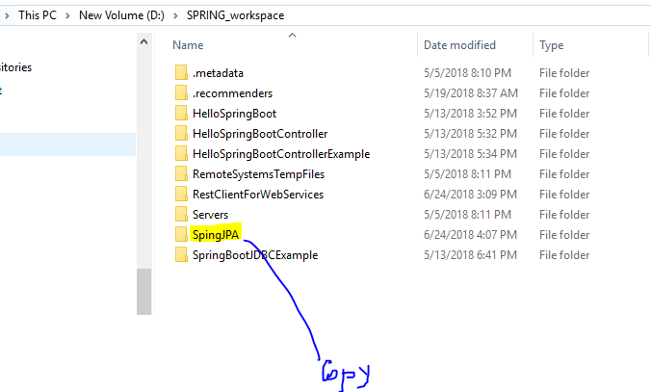

And paste the same inside the newly created folder where we performed ‘Git Clone’

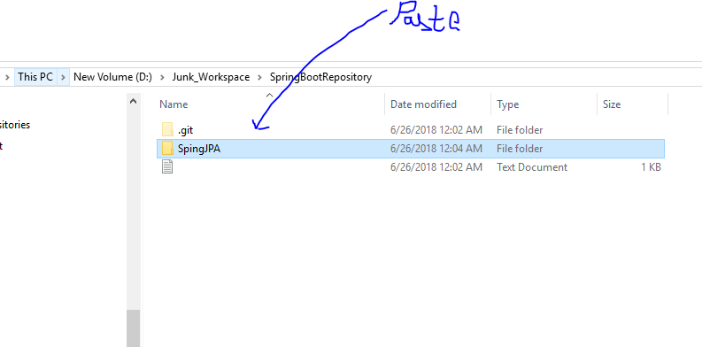

Now, initiate the Git Bash Here -

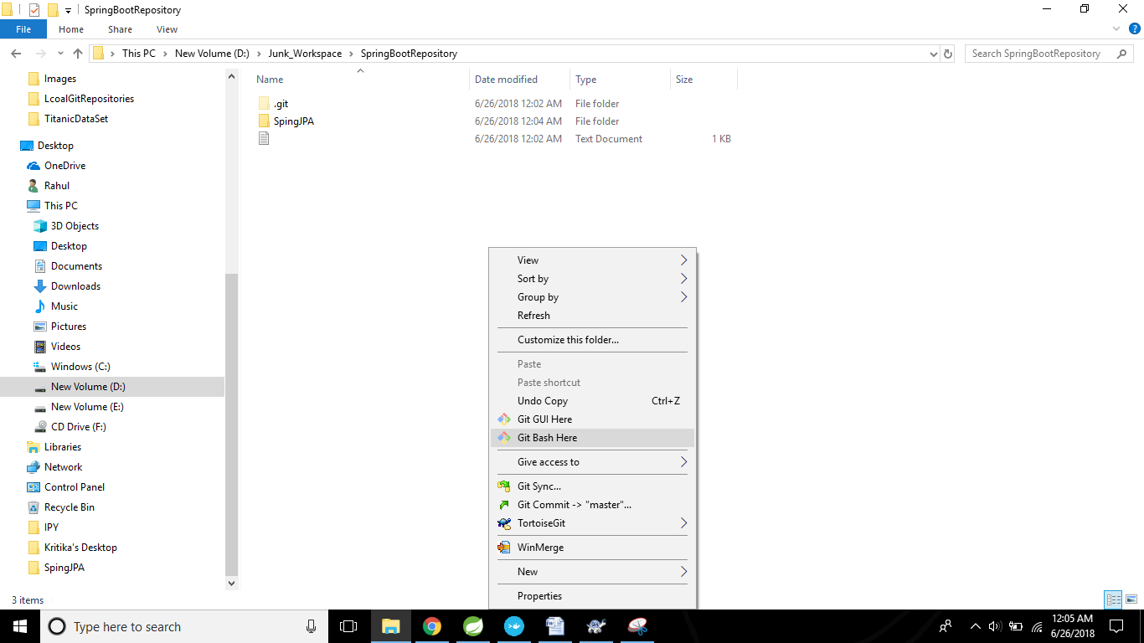

Step#1: The new comer is marked as **Red**

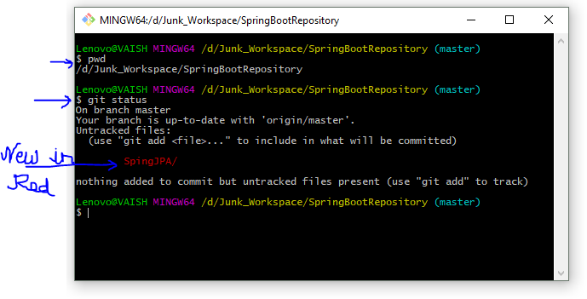

Step#2: Registering:

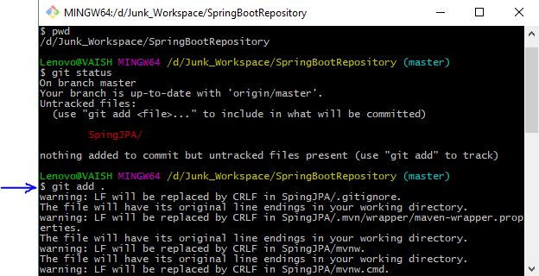

The above command can be lexically analyzed as **git add <.>**.Here <.> means all. If there were few specific files we wanted to commit we have two ways Because we wanted to commit and push our changes into **master** branch so we mentioned the same. If instead, we were interested to commit and push our changes into any specific branch, then we would have mentioned the other name.

Step#3: Checking the status again. It looks **Green**.

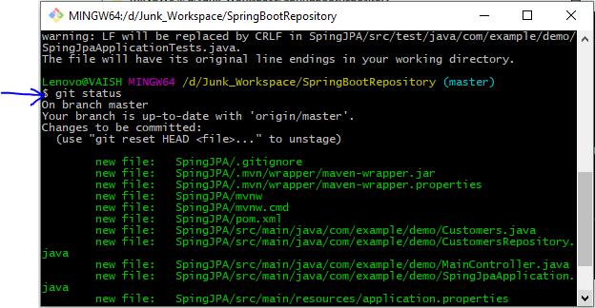

Step#4: Commit

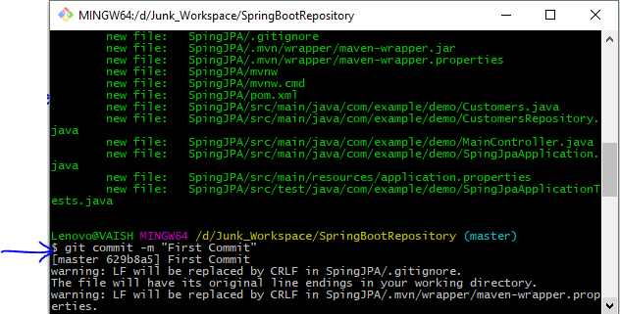

Step#5: Pushing the commit (here on master branch).

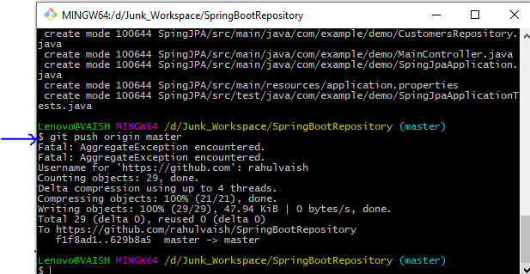

The above command can be lexically analyzed as **git push origin <the branch we want to commit our changes>**.Because we wanted to commit and push our changes into **master** branch so we mentioned the same. If instead, we were interested to commit and push our changes into any specific branch, then we would have mentioned the other name.

For example: git push origin SpringBootDockerExample. In this command SpringBootDockerExample is the name of branch.

Step#6: Check Github.com

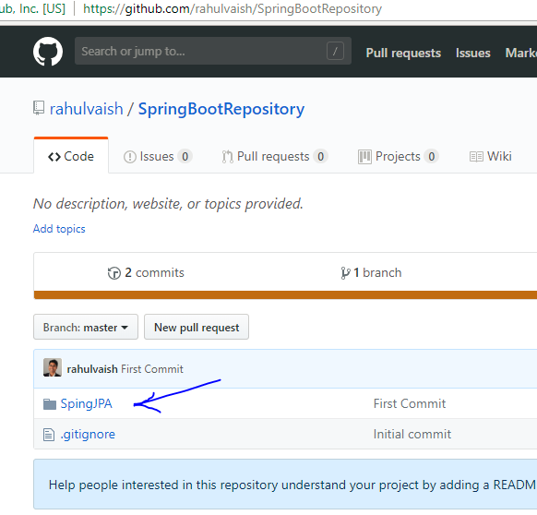

As you see that copy paste doesn’t looks very fine, therefore another approach is not to copy paste the project but after you perform Git clone activity make the same folder your eclipse workspace.

Once done, initiate Git Bash -> git status -> git add <Project Name> Don’t do <.> this time as now it is a workspace and it has lotss of eclipse files-> git commit –m “Message” -> git push origin <branch name>

**TORTOISE GIT TOOL**

**To avoid these hassles of Git Bash, you can also use Tortoise Git tool.**

**R/C -> Git Commit master -> select the files -> commit -> push**

**The option Git Commit Master appears because its by default. If you wanted to commit on any other branch then you should have R/C->switch checkout-> select the desired branch as soon as you cloned the repository.**

If you forgot that, no problem, Git bash gives you flexibility to choose the Branch during command execution.